**Unit 9 - Math Review Packet #1**

**Name:__________________**

**Mr. Ortega**

**8th Grade Math**

Name:___________________________ Date:_______________

**Learning Target: ______________________________________________________________**

**____________________________________________________________________________________________________________________________________________________________**

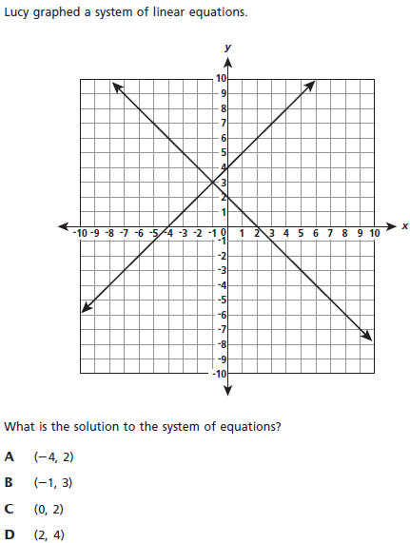**1.**

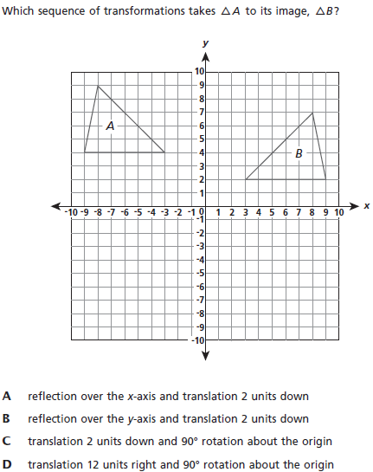**2.**

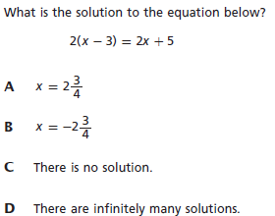**3.**

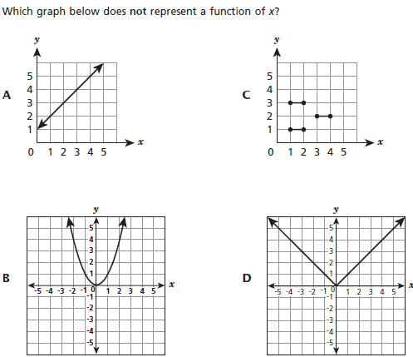**4.**

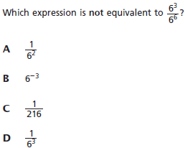

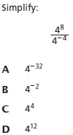**5. 6.**

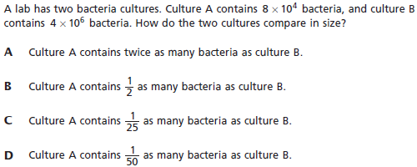**7.**

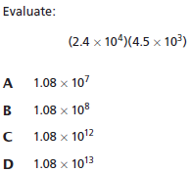**8.**

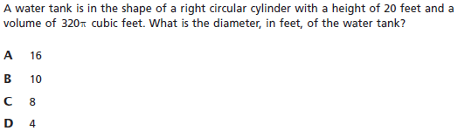**9.**

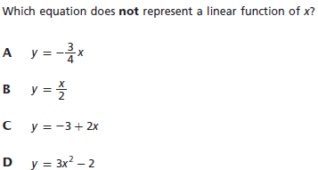**10.**

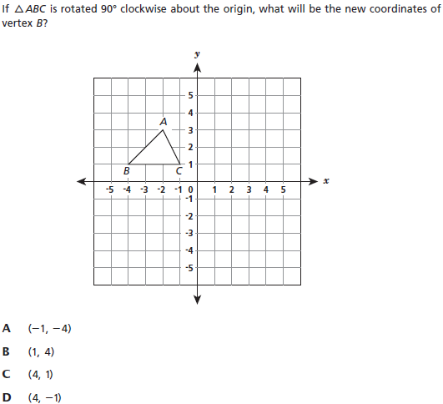**11.**

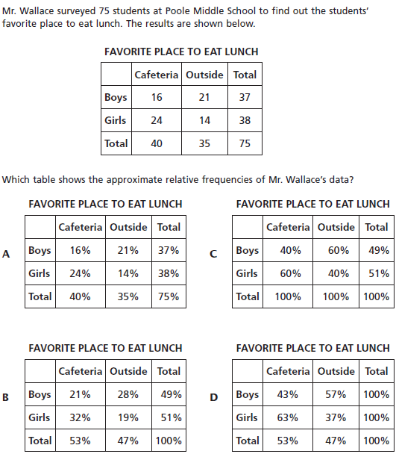**12.**

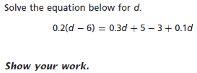**13.**



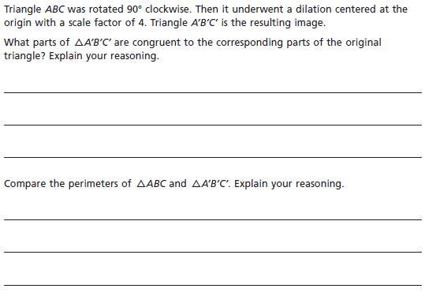**14.**

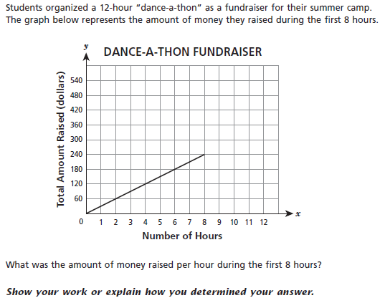**15.**



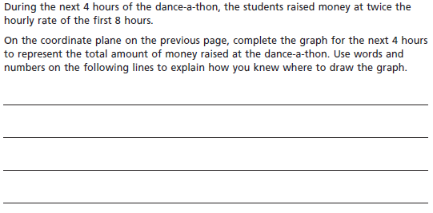

**Name: _____________________ Class: _________________**

**M8-U8: Notes & HW #2**

**1.** You have a coupon worth $18 off the purchase of a scientific calculator. At the same time the calculator is offered with a discount of 15%, but no further discounts may be applied. For what tag price on the calculator do you pay the same amount for each discount?

**2.** In ,  is a bisector of . The measure of  is . What is the measure of ? *Justify your answer.*

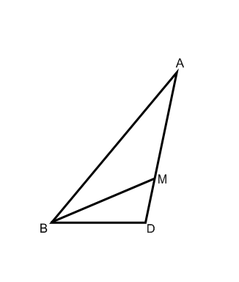

________________________________

________________________________

________________________________

________________________________

**3.** In  point *M* is the point of intersection of the bisectors of  and . The measure of  is , and the measure of  is . What is the measure of ? *Justify your answer.*

________________________________

________________________________

________________________________

________________________________

**4.** Triangle *A* and its image Triangle *A'* are shown below. Describe a sequence of transformations that maps Triangle *A* onto Triangle *A'*.



Is the resulting figure similar or congruent? *Explain.*

**5.** A trainer for a professional football team keeps track of the amount of water players consume throughout practice. The trainer observes that the amount of water consumed is a linear function of the temperature on a given day. The trainer finds that when it is 90°F the players consume about 220 gallons of water, and when it is 76°F the players consume about 178 gallons of water.

**Part A:** Write a linear function to model the relationship between the gallons of water consumed and the temperature.

**Part B:** Explain the meaning of the slope in the context of the problem.

**6.** Which statement about this system of equations is true?

*y* = (8*x* + 4)

*y* – 4*x* = 2

*(Circle the correct answer.)*

**a.** It has no solution. **c.** (0, 2) is the only solution.

**b.** (2, 0) is the only solution. **d.** It has infinitely many solutions.

**7.** Which of the following could be modeled by ? Answer YES or NO for each one.

**a.** There are initially 5 rabbits on the farm. Each month thereafter the number of rabbits is 2 times the number in the month before. How many rabbits are there after *x* months?

YES NO

**b.** Joaquin earns $2.00 for each magazine sale. Each time he sells a magazine he also gets a five-dollar tip. How much money will he earn after selling *x* magazines?

YES NO

**c.** Sandy charges $2.00 an hour for babysitting. Parents are charged $5.00 if they arrive home later than scheduled. Assuming the parents arrived late, how much money does she earn for *x* hours?

YES NO

**d.** Sneak Preview is a members-only video rental store. There is a $2.00 initiation fee and a $5.00 per video rental fee. How much would John owe on his first visit if he becomes a member and rents *x* videos?

YES NO

**e.** Andy is saving money for a new CD player. He began saving with a $5.00 gift and will continue to save $2.00 each week. How much money will he have saved at the end of *x* weeks?

YES NO

**8.** Consider the graph below showing two lines, *L1* and *L2*.



**a.** What is the solution to the above system?

**b.** Find the two corresponding linear equations.

**c.** Find a point other than the ones given in the graph that lies on *L1* but not on *L2*.

**d.** Find a point other than the ones given in the graph that lies on *L2* but not on *L1*.

**9.** Simplify the expression: . Express your answer using a positive exponent.

**a.**  **b.** 

**c.**  **d.** 

**10.** Jane suspects that there is a relationship between the number of text messages high school students send and their academic achievement. To explore this, she asks each student in a random sample of 52 students from her school how many text messages he or she sent yesterday and what his or her grade point average (GPA) was during the most recent marking period. The data are summarized in the scatter plot of number of text messages sent versus GPA shown below.



Describe the relationship between number of text messages sent and GPA.

________________________________________________________________________

________________________________________________________________________

________________________________________________________________________

________________________________________________________________________

________________________________________________________________________

________________________________________________________________________

**11.** My sister’s birthday is in a few weeks and I would like to buy her a new vase to keep fresh flowers in her house. She often forgets to water her flowers and needs a vase that holds a lot of water.

In a catalog there are three vases available and I want to purchase the one that holds the most water.

* The first vase is a cylinder with diameter 10 cm and height 40 cm.
* The second vase is a cone with base diameter 16 cm and height 45 cm.
* The third vase is a sphere with diameter 18 cm.



**a.** Which vase should I purchase?

**b.** How much more water does the largest vase hold than the smallest vase?

**c.** Suppose the diameter of each vase decreases by 2 cm. Which vase would hold the most water?

**12.** Which step would *not* be a possible first step for solving the following equation algebraically?



**a.** subtract  from both sides of the equation

**b.** subtract 6 from both sides of the equation

**c.** multiply  by 

**d.** multiply  by 

**13.** The graph below models the cost of holding a banquet at the Tea Room restaurant.

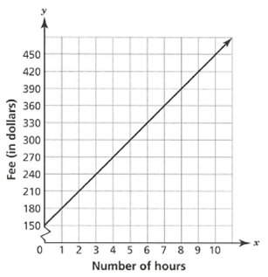

What is the initial fee and cost per hour to hold a banquet at the Tea Room?

**a.** fee: $150, cost per hour: $30 **c.** fee: $120, cost per hour: $30

**b.** fee: $30, cost per hour: $150 **d.** fee: $30, cost per hour: $120

**14.** Due to plate tectonics, the summit of Mount Everest moves about  meters northeastward in one year. How many meters does the summit of Mount Everest move in 11 years? Express your answer in scientific notation.

**a.**  meters **c.**  meters

**b.**  meters **d.**  meters

**15.** Figure *A* and its image after a transformation, Figure *A’*, are shown on the coordinate plane below. The two figures are congruent.

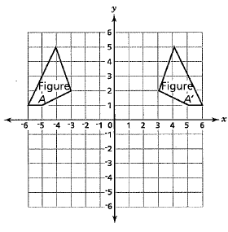

How was Figure *A* transformed to create the congruent Figure *A’*?

**a.** It was reflected across the *x*-axis

**b.** It was reflected across the *y*-axis

**c.** It was translated 9 units to the right

**d.** It was rotated 90o clockwise around the origin

**16.**

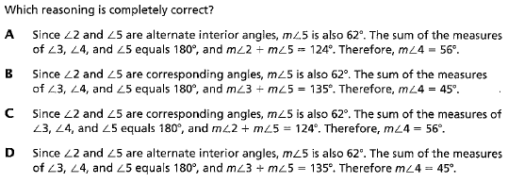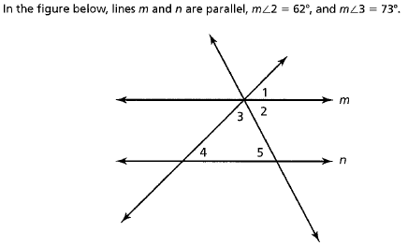

**17.** The table below shows the hours worked last week by employees at an insurance company.

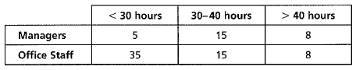

Of all the employees, what is the approximate relative frequency of managers who worked more than 40 hours?

**a.** 8% **b.** 9.3%

**c.** 28.8% **d.** 40%

**18.** In which interval is the graph below linear and increasing?

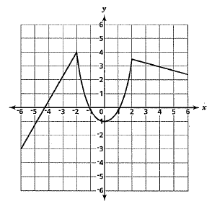

**a.** from *x* = -6 to *x* = -2 **b.** from *x* = -2 to *x* = 0

**c.** from *x* = 0 to *x* = 2 **d.** from *x* = 0 to *x* = 6

**19.** What is the rate of change and initial value of the linear function modeled by a line passing through the points (0, 8) and (3, -1)?

**a.** rate of change: -3; initial value: 8

**b.** rate of change: -3; initial value: -8

**c.** rate of change: 8; initial value: 3

**d.** rate of change: 8; initial value: -3

**20.** The height of a falling object can be modeled by the equation  where  is the initial velocity in feet per second, *t* is time in seconds, and  is the initial height in feet. Is the function linear or nonlinear, and why?

**a.** It is linear, because the object falls in a straight line.

**b.** It is linear, because the object falls at a constant speed.

**c.** It is nonlinear, because the object does not fall in a straight line.

**d.** It is nonlinear, because the object does not fall at a constant speed.

**20.** Which expression is *not* equivalent to ?

**a.**  **c.** 

**b.**  **d.** 

**21.** Consider the pair of linear equations below.



Does the system of equations have one solution, no solution, or infinitely many solutions? Explain.

________________________________________________________________________

________________________________________________________________________

________________________________________________________________________

________________________________________________________________________

________________________________________________________________________

________________________________________________________________________

**22.** The equation  models the relationship between the number of video games, *x*, a company manufactures and the cost in dollars, *y*, to manufacture that number.

**Part A**

Fill in cost in dollars to manufacture different numbers of video games.

|  |  |
| --- | --- |
| **Number of Video Games, *x*** | **Cost (in dollars), *y*** |
| 0 |  |
| 50 |  |
| 100 |  |
| 150 |  |
| 200 |  |

**Part B**

Plot the points on the coordinate grid.

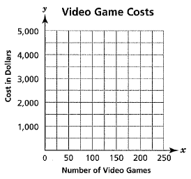

**Part C**

Does the equation  represent a linear function? Explain your answer.

________________________________________________________________________

________________________________________________________________________

________________________________________________________________________

________________________________________________________________________

**Name: _____________________ Class: _________________**

**M8-U8: Notes & HW #3**

**1.** David currently has a square garden. He wants to redesign his garden and make it into a rectangle with a length that is 3 feet shorter than twice its width. He decides that the perimeter should be 60 feet.

Determine the dimensions, in feet, of his new garden.

***Show your work. Only an algebraic solution will be accepted.***

**2.** In the picture below, lines *l* and *m* are parallel. The measure of , and the measure of . What is the measure of ? *Justify your answer.*



________________________________

________________________________

________________________________

________________________________

**3.** Identify the transformation from the original to the image, and tell whether the two figures are similar or congruent.

Original  vertices are: *E*(–3, 1), *F*(1, 1), and *G*(4, 5)

Image  vertices are: *E’*(–3, –1), *F’*(1, –1), and *G’*(4, –5)

**4.** In the diagram below, Δ*ABC* is similar to Δ*ART*.



**Part A:** What is the scale factor from Δ*ABC* to Δ*ART*?

**Part B:** If the slope of *AC* is –2, what is the value of *x* for coordinate *C*?

**Part C:** Using the information from parts A and B, what is the length of *RT*?

**5.** A circular pond is mapped onto its image by transformation. Describe the transformation.

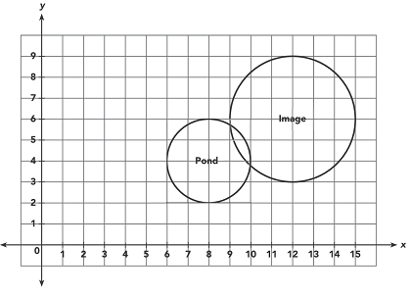

*(Circle the correct answer.)*

**a)** dilation with center (0, 0) and scale factor -1.5

**b)** dilation with center (0, 0) and scale factor 1.5

**c)** dilation with center (8, 4) and scale factor -1.5

**d)** dilation with center (8, 4) and scale factor 1.5

**6.** Which statement about this system of equations is true?



*(Circle the correct answer.)*

**a.** It has no solution. **c.** (0, 1) is the only solution.

**b.** (1, 0) is the only solution. **d.** It has infinitely many solutions.

**7.** You work for a video streaming company that has two monthly plans to choose from:

**Plan 1:** A flat rate of $7 per month plus $2.50 per video viewed

**Plan 2:** $4 per video viewed

**a.** What type of functions model this situation? *Explain* how you know.

**b.** Define variables that make sense in the context, and then write an equation with cost as a function of videos viewed, representing each monthly plan.

**c.** How much would 3 videos in a month cost for each plan? 5 videos?

**d.** Compare the two plans and explain what advice you would give to a customer trying to decide which plan is best for them, based on their viewing habits.

**8.** Multiply: . Write the product as one power.

**a.**  **b.** 

**c.**  **d.** Cannot be combined

**9.** Which of the following is the fastest unit rate? *Justify your choice.*

*(Circle the correct answer.)*

**a.** 30 miles per hour **b.** 700 yards per minute

**c.** 40 feet per second **d.** 2,200 feet per minute

**10.** The temperature in a city began to decrease at a constant rate once a cold front began to move in The temperature was 49oF after 2 hours and 39oF after 6 hours. Suppose *x* is the number of hours since the cold front began to move in, and *y* is the temperature in oF.

Which equation models this situation?

**a.**  **b.** 

**c.**  **d.** 

**11.** The planet of Mercury is approximately  miles from the sun. The distance between the Sun and Mars is approximately  miles. ***About*** how many times farther from the Sun is Mars than Mercury?

**a.** 2 **c.** 20

**b.** 3 **d.** 30

**12.** A pair of lines intersect at the point (-3, 4). Which pair of equations could represent these lines?

*(Circle the correct answer.)*

**a.**  **c.** 

**b.**  **d.** 

**13.** The two triangles shown are similar.

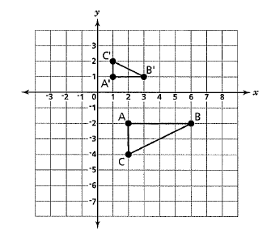

Which series of transformations could have been used to transform triangle *ABC* into the similar triangle *A’B’C’*?

**a)** a dilation about the origin with a scale factor of 0.25 and a reflection across the *x*-axis

**b)** a dilation about the origin with a scale factor of 0.25 and a reflection across the *y*-axis

**c)** a dilation about the origin with a scale factor of 0.5 and a reflection across the *x*-axis

**d)** a dilation about the origin with a scale factor of 0.5 and a reflection across the *y*-axis

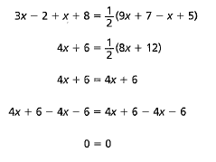**14.** Melinda transformed the equation  into a simpler form as shown

Which statement is correct?

**a)** Melinda made a mistake; the equation has no solution.

**b)** Melinda did everything correctly; the equation has no solution.

**c)** Melinda made a mistake; the equation has an infinite number of solutions.

**d)** Melinda did everything correctly; the equation has an infinite number of solutions.

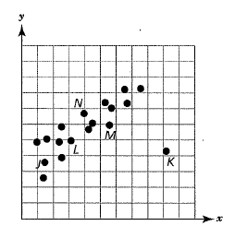**15.** Look at the scatter plot below. Liza used points *J* and *K* to draw a line of best fit for the data. Derek used points *J* and *M* to draw a line of best fit.

Which reason best explains why Derek’s line is a better model for the data?

**a)** Since point *J* is close to the other points, Derek’s line would also be close.

**b)** Since Derek’s line has a positive slope, it can be used as the line of best fit.

**c)** Since point *K* is a data point, Liza’s line can pass through it and still fit the data.

**d)** Since point *K* is an outlier, Liza’s line would be far from most of the other data points.

**16.** Aaron graphed the equation  on a coordinate plane, while Jody graphed the equation . The ordered pair (1, 1) satisfies both equations. Which statement about the ordered pair (1, -1) is correct?

**a)** It shows that Jody did not graph a function.

**b)** It shows that Aaron did not graph a function.

**c)** It satisfies both equations.

**d)** It satisfies neither equation.

**17.** , and  intersect at point *G*.

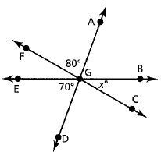

What is the value of *x*?

**a.** 10 **c.** 30

**b.** 20 **d.** 40

**18.** A cylindrical water tank near the town library is 15 meters high and has a circumference of 85 meters. What is the ***approximate*** volume, to the nearest whole number, of the water tank?

**a.** 1,275 m3 **c.** 8,624 m3

**b.** 2,875 m3 **d.** 34,497 m3

**19.** In the graph below, time is shown on the *x*-axis and the distance is shown on the *y*-axis. The slope of a segment represents the speed during that interval.

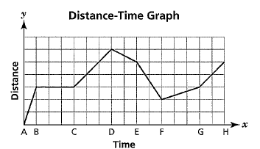

Which statement is *true*?

**a)** The object is moving closer to its starting position most quickly between A and B.

**b)** The object is moving closer to its starting position most quickly between E and F.

**c)** The object is moving farther away from its starting position most quickly between

C and D.

**d)** The object is moving farther away from its starting position most quickly between

D and E.

**20.** Benjamin and Layla each deposited a set amount of money into their savings accounts each month. The graph below shows the total amount Benjamin has in his account after making his deposit each month.

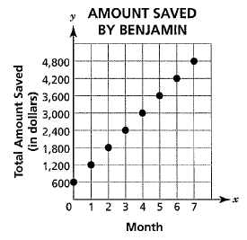

The table below represents the total amount Layla has in her account after making her deposit each month.

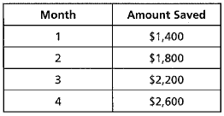

Using *y* as the number of dollars saved and *m* as the number of months where *m* is a positive integer, which equation models the account that is growing at the faster rate?

**a.**  **c.** 

**b.**  **d.** 

**21.** Mark used a graph to compare the wages from two restaurant jobs. A dishwasher earns $7.25 per hour, while a waiter earns $3.75 per hour in addition to $25 per day.

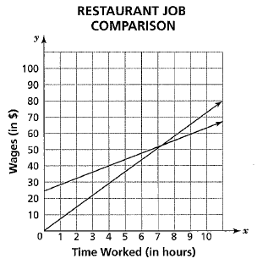

**Part A**

To the nearest hour, when will the two jobs earn the same amount?

***Answer* _______________________** hours

**Part B**

Explain why your estimate is reasonable.

________________________________________________________________________

________________________________________________________________________

________________________________________________________________________

________________________________________________________________________

**22.** Michael has 52 boxes. There are 51 kg of apples in each box.

When empty, a box weighs 5-2 kg.

**Part A**

What is the total weight of Michael’s boxes, when empty?

***Show your work.***

***Answer* _______________________** kg

**Part B**

How many kilograms of apples does Michael have in all?

***Show your work.***

***Answer* _______________________** kg

**Part C**

What is the total weight of Michael’s boxes with the apples in them?

***Show your work.***

***Answer* _______________________** kg